Send an instant message
- In your Contacts list, double-click a contact.
- Type a message in the message input area at the bottom of the message box, and then press Enter.
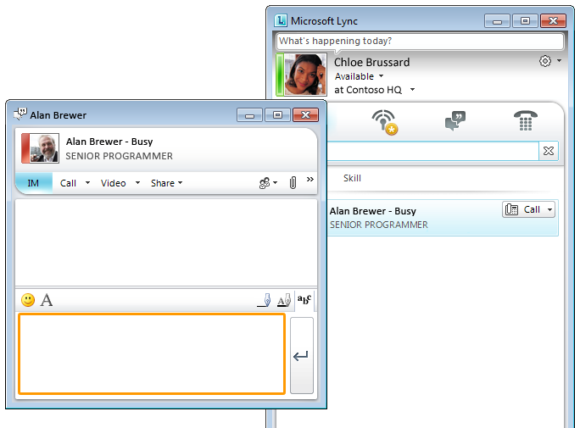
- (Optional) To add an emoticon, click the emoticon (smile face) button.
- (Optional) To customize the font, such as type or size, click the letter A next to the emoticon button.
Receive an instant message
When someone sends you an instant message, an instant message alert appears in the lower-right corner of your computer screen. Do one of the following:
- To accept the invitation, click the alert.
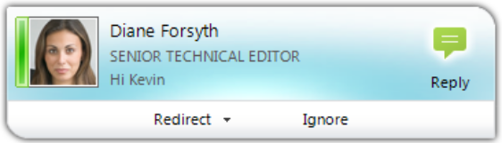
- To redirect the invitation, click Redirect.
- To decline the invitation, click Ignore.
PRINT SETTINGS For best results, set printer options to: Paper Size: Letter (8.5x11”); Orientation: Landscape; 2-sided printing options: Two-sided, flip on short side.

© 2011 Microsoft. All Rights Reserved. This document is provided “as-is”. Information and views expressed in this document, including URL and other Internet Web site references, may change without notice. You bear the risk of using it. Some examples are for illustration only and are fictitious. No real association is intended or inferred.


Instant Messaging and Presence Quick Reference
First 5 minutes: Sign in and get started
If you’re already logged on to your organization’s network, signing in is as easy as starting Microsoft® Lync™ 2010.
- On the Start menu, click All Programs, click Microsoft Lync, and then click Microsoft Lync 2010.
- Click your presence status if you want to change it, or click Reset Status to let Lync 2010 set your status automatically based on your activity or Microsoft® Outlook calendar.
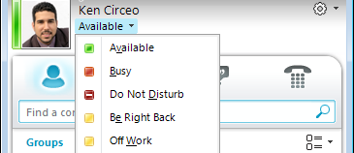
- Set a location to let people know where you are today.
- Let them know what you’re up to by clicking What’s happening today? and typing a note.
What does your presence state mean?
Available | You are online and available for contact.
Busy | You are in a Lync phone call or, according to your Outlook calendar, you are in a meeting.
Do not disturb | You don’t want to be disturbed and will see conversation alerts only if they are sent by your Workgroup contacts.
Be right back | You are away briefly and will return shortly.
Away | Your computer has been idle (for 15 minutes, by default).
- Off Work | You are not working and are not available to contact.
Offline | You are not signed in. If you have blocked individuals from seeing your presence, you’ll always appear offline to them.
Personalize your contact info
You can personalize your contact and presence information. For example, you can add your mobile phone number and make it available only to close contacts.
- In the Lync main window, click the Options button, and then click Phones.
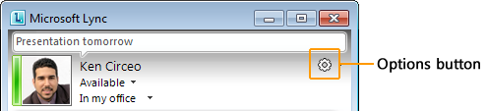
- Click the button for the phone number, and then click OK.
- Select the Include in my contact card check box, and then click OK.
- To let certain people see your personal numbers: in your Contacts list, right-click the contact’s name, click Change Privacy Relationship, and then click Friends and Family.
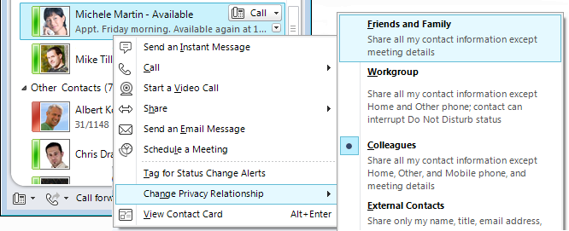
Change your photo settings
You can decide whether you want to see your contacts' photos. You can also change your own photo or choose not to show one.
- Click the Options button, and then click Personal.
- Under Display photo, to hide other people’s photos, clear the Show photos of contacts check box.
To change your photo, first upload the new photo to an unauthenticated website (such as Windows Live®). The file must be less than 30 KB in size.
- Click the Options button, and then click My Picture.
- Click Show a picture from a web address, type the web address including the file name, click Connect to Picture, and then click OK.
Find the right person
Just start typing a person’s name in the search box, and results will appear below the box. If you see who you’re looking for, double-click the person’s name to send an instant message.
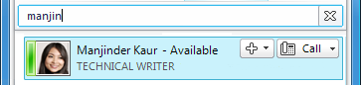
If you’re not sure you’ve found the right person, the contact card gives more information and shows where the person fits into the organizational tree.
- To display the contact card, point to the person’s picture.
- For a full version, click the down arrow in the lower right corner. Then, to see his or her organization, click the Organization tab.
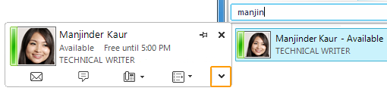
Build your Contacts list
Add people to your Contacts list if you'll be contacting them often or if you just want to keep track of them.
- In the search box, type the person’s name or email address.
- In the search results, right-click the person, and then do one of the following:
- If you’ll be contacting them often, click Pin to Frequent Contacts.
- Add them to a group by clicking Add to Contact List and then clicking the group name.
- If you haven’t created groups yet, click Add to New Group, and give the group a name. You can add more contacts to this group later.
(Optional) To make sure you know when someone becomes available, right-click the contact’s name, and then click Tag for Status Change Alerts.

